US EMISSION DASHBOARD

1. Project Overview: U.S. Emissions Analysis Dashboard (EPA)
The Environmental Protection Agency (EPA) commissioned this project to develop an interactive dashboard that provides a clear, data-driven view of greenhouse gas emissions across the United States. The primary objective is to identify where emissions are coming from, which regions contribute the most, and how emissions compare relative to population and geographic area.

Dataset Summary
The dataset is generated from Kaggle with total rows of 3,142 and 58 columns. The table contains data related to emissions at the county level, including demographic and geographic information. It includes metrics such as population, employment, energy consumption, and greenhouse gas emissions. This data can be used for analyzing trends in emissions, understanding the impact of population and economic factors on emissions, and supporting environmental assessments.
the key features :
- Geographic Identifiers (state_id, state_abbr, county_id, county_namem county_state_name, latitude, longitude, doe_climate_zone, consolidated_city-county)
- Demographics & Socioeconomic Data (population, population_cohort, employment, employment_cohort, occuped housing units, establishments, buildings, area (sq. ft.)
- Energy Consumption Metrics
- Electricity (MWh): consumption (MWh), consumption (MWh/capita)
- Natural Gas (TcF): consumption (TcF), consumption (TcF/capita), Sector-level gas consumption columns
- Fuel & Transportation: consumption (gallons), consumption (gallons/capita), vehicle miles traveled (miles), vehicle miles traveled (miles/capita)
- Emissions Data (GHG emissions mtons CO2e)
- Economic & Utility Indicators (Multiple expenditures in Millions fields, utility customers (across energy sectors)

- Exploratory Data Analysis using Databricks
- Data Loading: Import the dataset
Create an account in Databricks using the free Edition. Create a new catalogue named “emissions”, inside your catalogue, click on the create button to create a table, on the create table pane, browse to import your dataset e.g emissions_data.
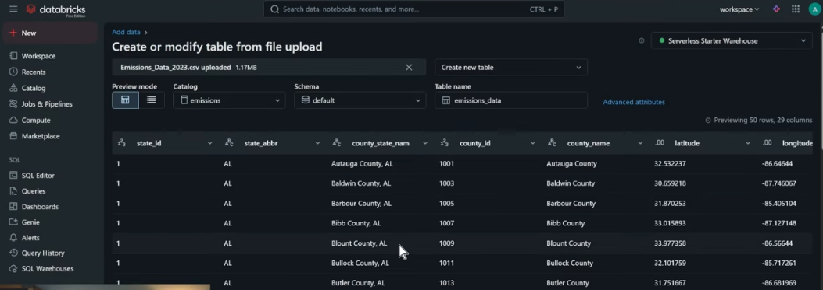
- Data Integrity: Converting column data type
Convert column datatype from string to double using Cast, Replace functions or Regexp
e.g. 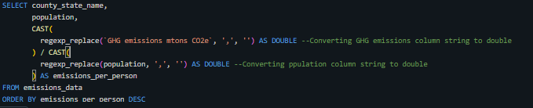

- Data Analysis using SQL (Business Transaction)
Structured analysis was performed in Databricks SQL Editor to answer key business questions
At the Databricks sidebar, click on SQL Editor, then, New Query to write your queries. Set your workspace to “emissions”.
- Emissions by location/Geographic : Compared emissions in highly density area vs low density area.
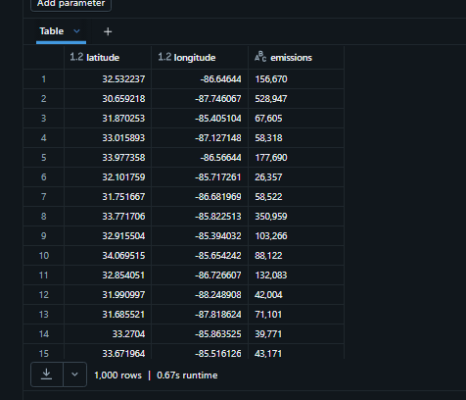
- Emissions vs Population: Compared emissions per person for each state.
NB: You may use AI Assistant to generate the SQL code eg, “I want to look at emissions per person in each county.”
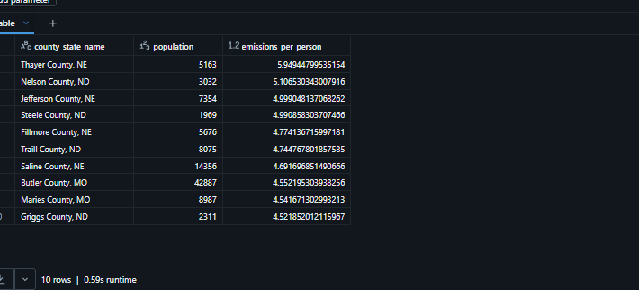
- Emissions vs State : Top 10 worst states in America
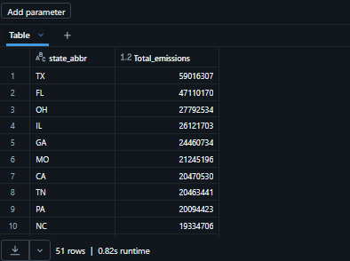
NB: You can use Ai Assistant to get the percentage amount for the top 10 states emissions for the country. Eg. using emissions_by_state query ask the Ai for example: “I want to know what percentage of emissions are the top 10 state for the whole country.
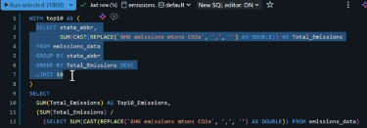
- Highest Top 10 Emissions by County (County shaming)
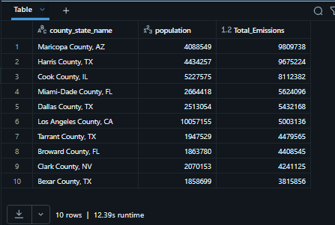
- Dashboard in Databricks
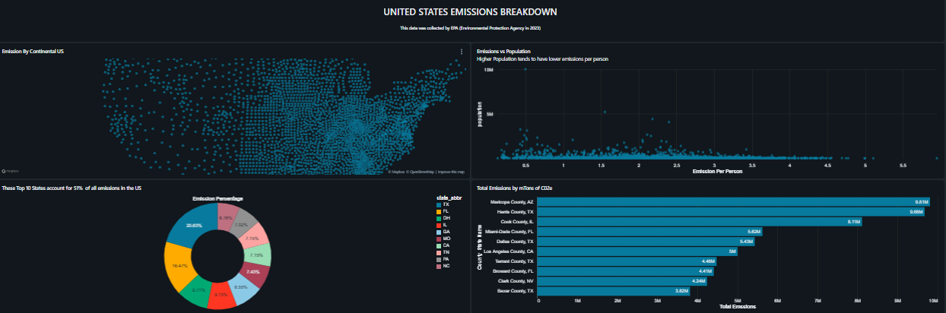

- Business Recommendations
- Target High-Emission Counties: Focus sustainability initiatives and investments in counties with the highest total emissions to maximize impact.
- Monitor Emission Trends: Regularly analyze changes in emissions over time to assess the effectiveness of current policies and adjust strategies accordingly.
- Allocate Resources Efficiently: Direct resources and funding to sectors or regions where emission reduction potential is greatest.
- Engage Stakeholders: Share dashboard insights with internal and external stakeholders to foster collaboration and transparency in sustainability efforts.
- Set Data-Driven Goals: Use dashboard metrics to establish measurable emission reduction targets and track progress towards these goals.

